The OSI Reference Model (Part 4)

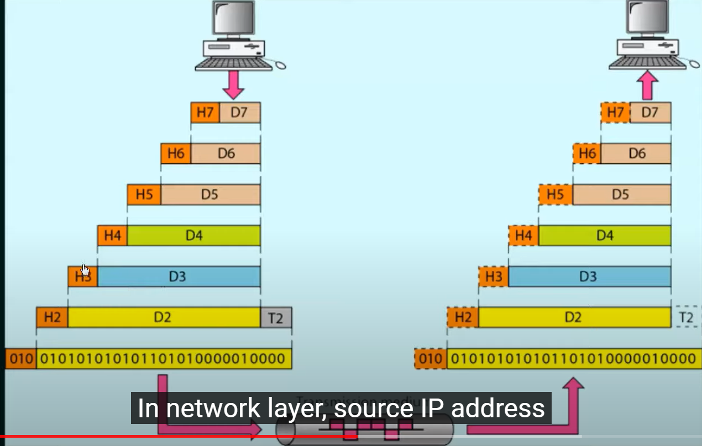

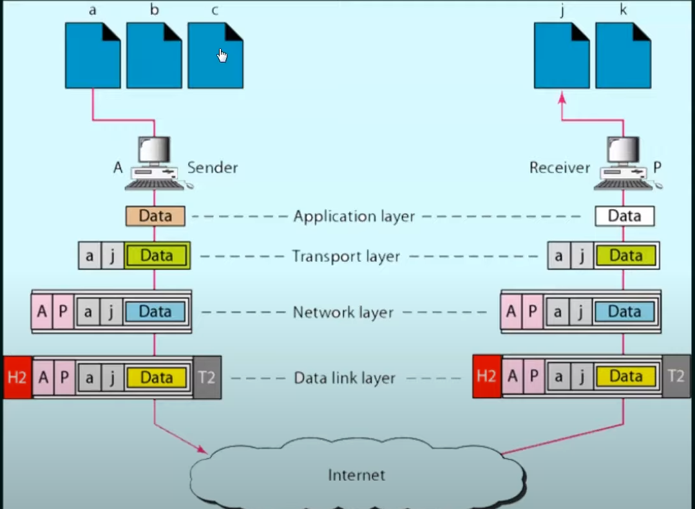

Note: When in data link layer putin the MAC addresses, finding the destination mac address is very hard so it puts the next router's MAC address instead.